Active checkbox in stores to elminate closed store so it will not appear in all transactions forms.

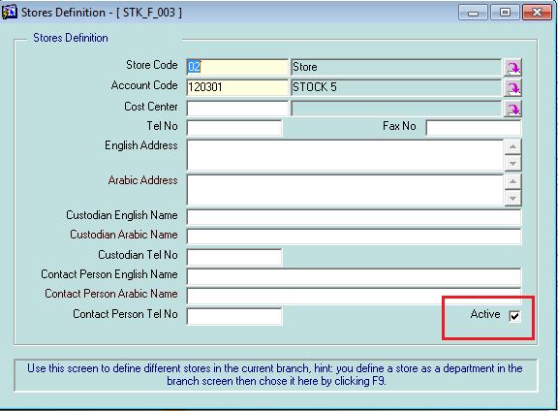

Items with serial number, the following screens is updated to reflect serial number

* Stores open balance
* Stock in document
* Stock out document
* Stock transfer
* Stocktaking
* Store disposal
* Purchase invoice
* Purchase return
* Purchase return document without invoice
* Sales delivery
* Sales invoice + sales invoice manager
* Sales return + Sales return manager
* Sales return items without invoice

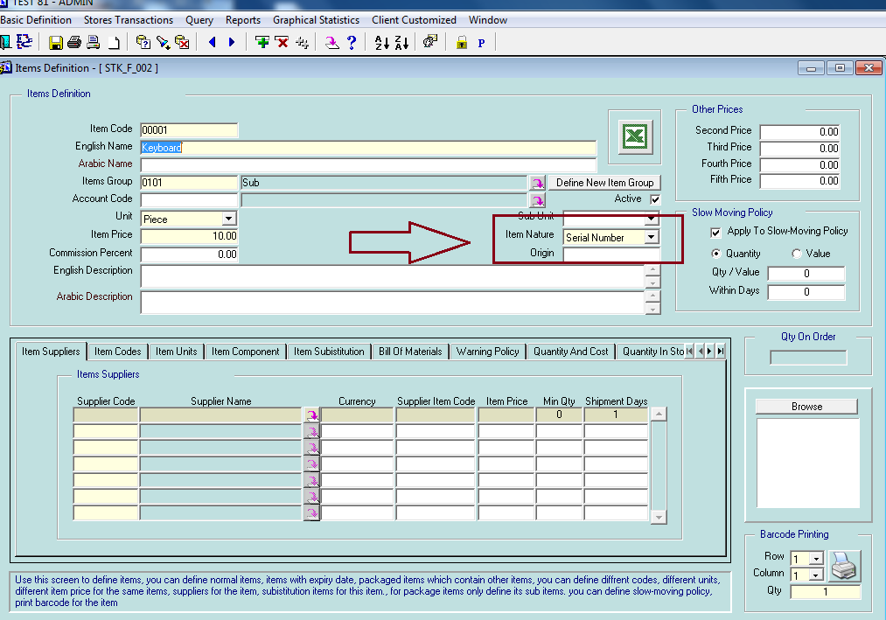

When u define item with serial number any transaction in stores, sales or purchase will ask u to enter the serial number related to it.

For example when u add items to the stores for example open balance for item with serial number the record will change color to pink as shown

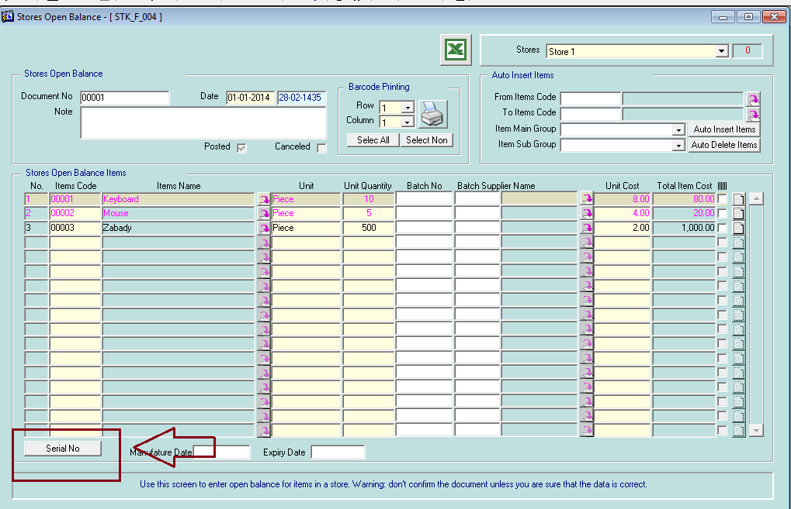

And the system will not allow u to post until u enter the serial number for the quantity entered as shown

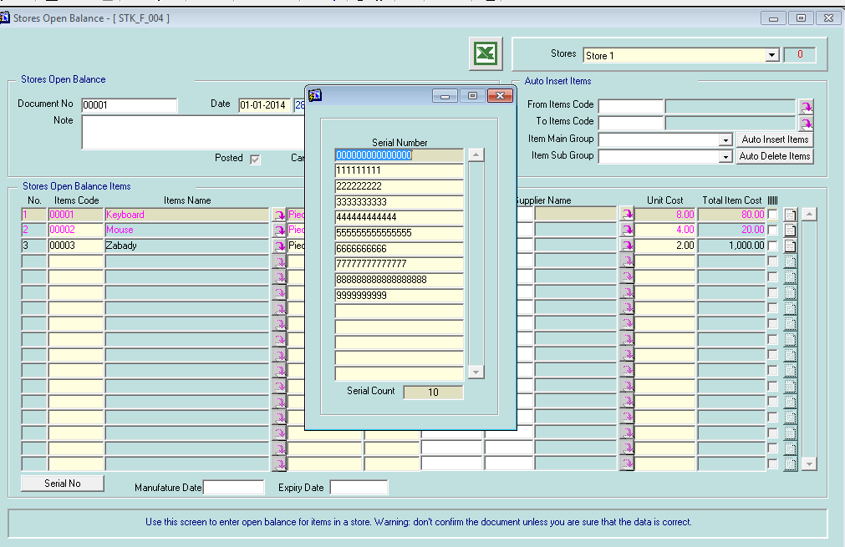

When u issue items with serial number for example stock out, the item with serial number can be chosen from the serial number already exist in store as shown

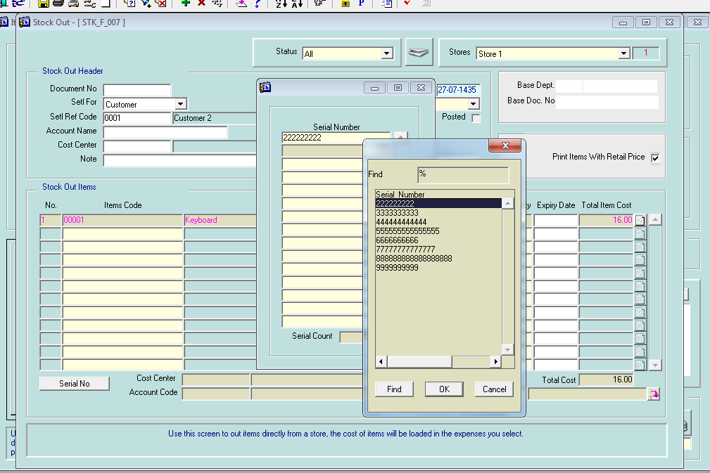

The same mechanism applies for all the stores documents, sales documents and purchase documents.

At any time u can check the quantity and it’s serial number in store

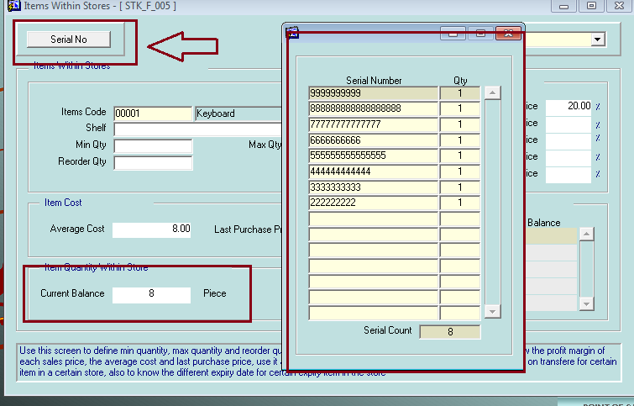

New report developed allow u to print the items and its quantity in store with their serial number

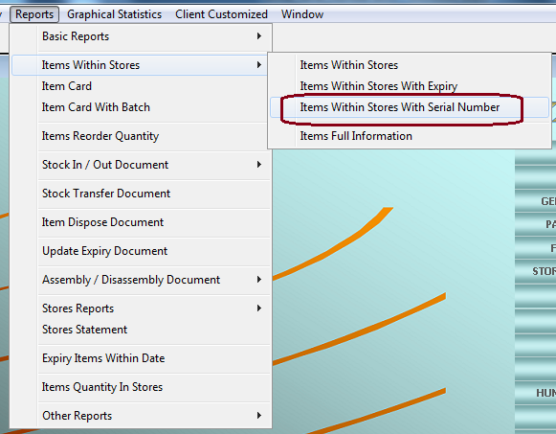

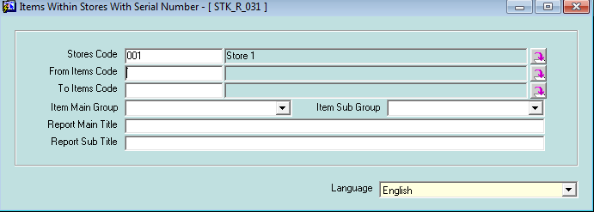

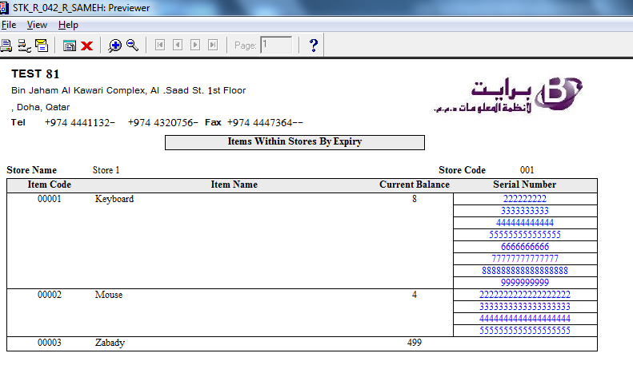

At any time you can print the history of serial number, to show all the transaction related to it, like when u buy it and from which supplier, when u sell it and for which customer,….

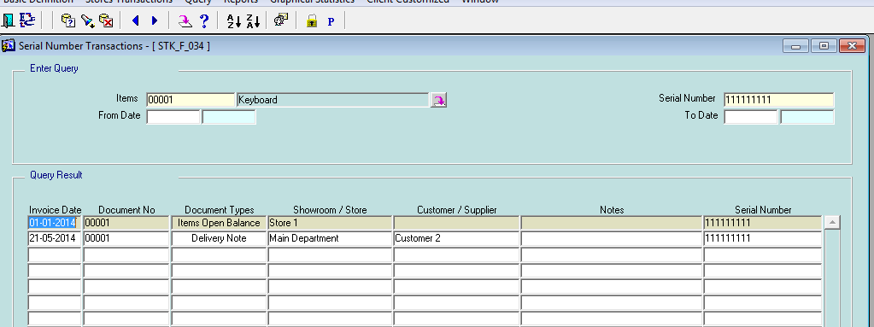

Create item group as a hierarchy tree

In previous version item groups only 2 levels and if the client want to create more than 2 levels we can’t, in this new version the item category can be tree with unlimited number of levels.

New screen has been added allow us to create categories for items as a tree with unlimited number of levels

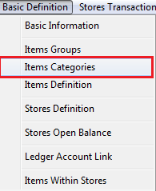

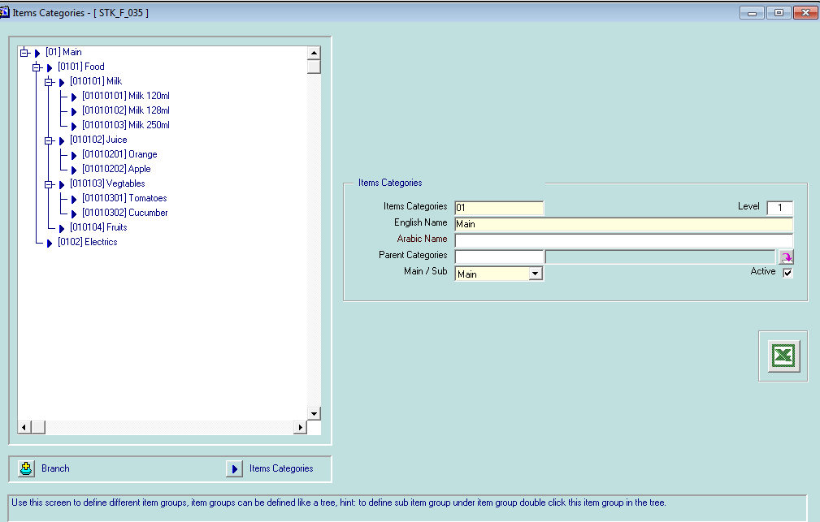

Item definition form has been update to include filed allow us to choose the item category

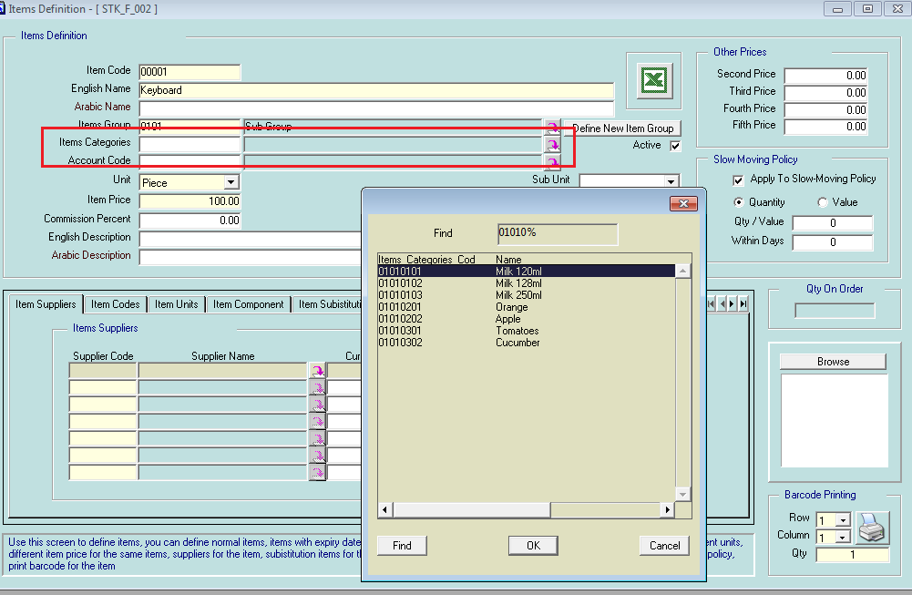

All queries and reports in store system has been updated to include from category – to category parameter

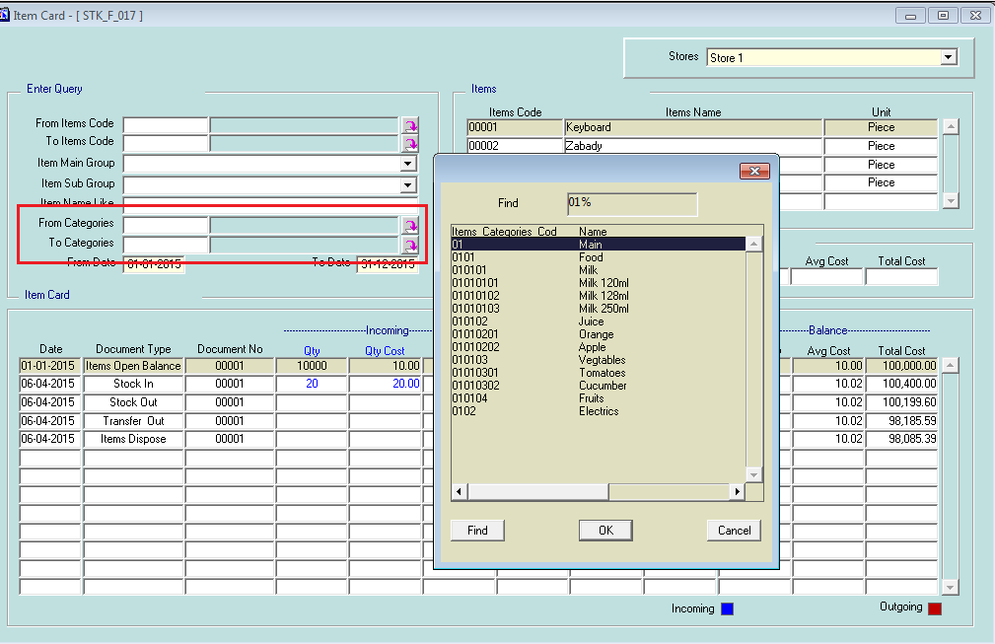

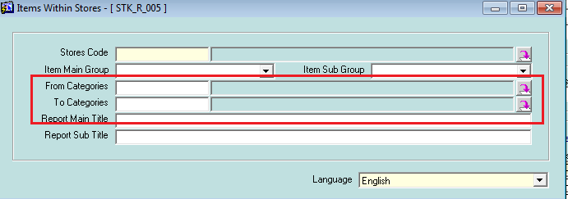

1-Show stock transfer transactions from The Total Quantities appearing in Item movement in / out Report dynamically with parameter so if user want to see all transactions for specific item so will set the parameter to unchecked and vise versa as shown in the next screenshots:

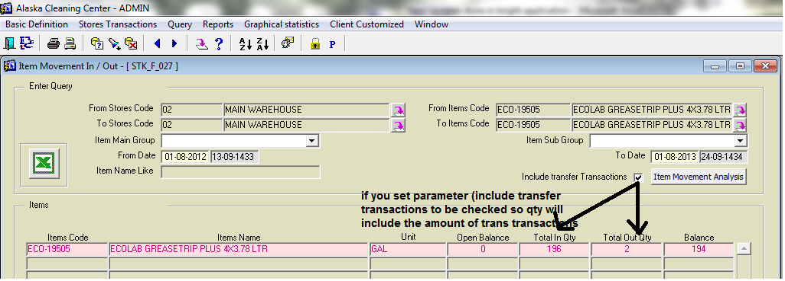

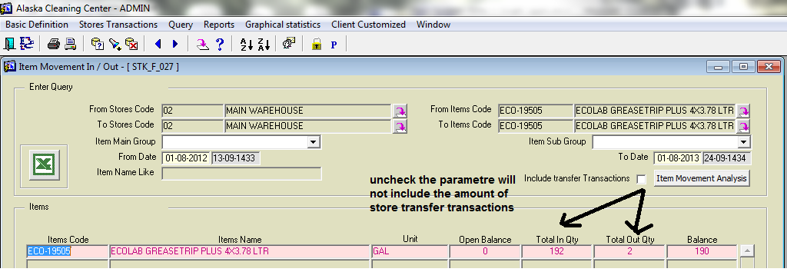

Item movement details screen is compatible to item movement in/out screen as following:

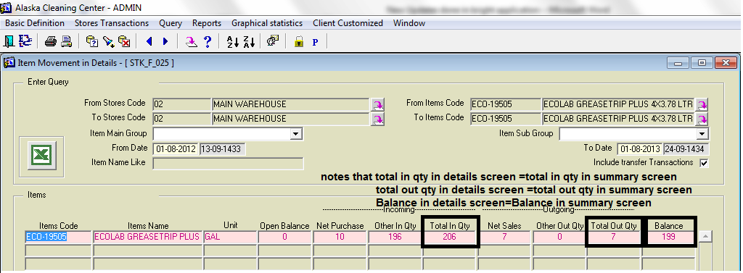

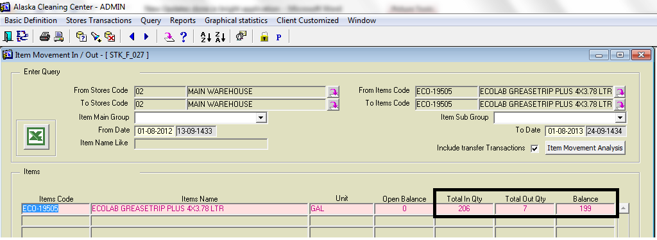

Also reports of the above screens give the same results.

2-new reports menu items added for our application as following: date 07-10-2013

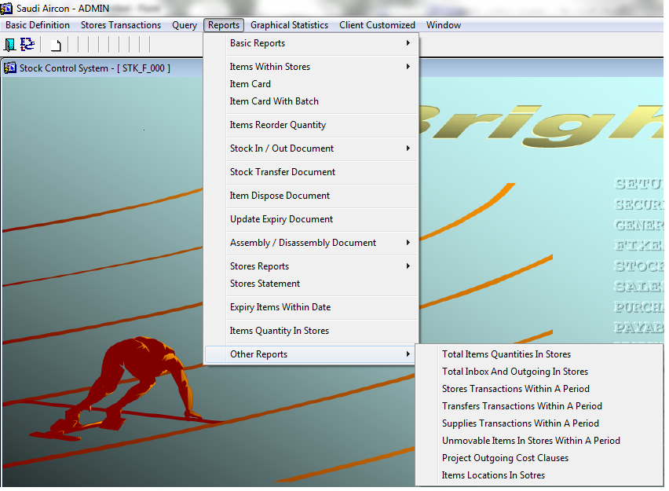

3-total items quantities in stores date 10-10-2013

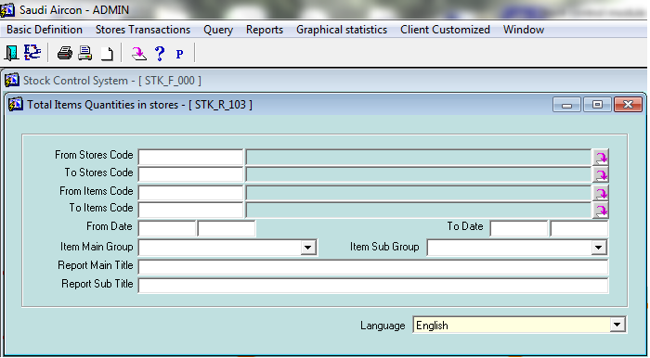

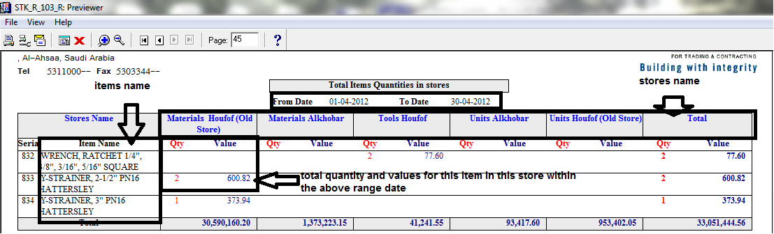

4.total inbox and outgoing in stores

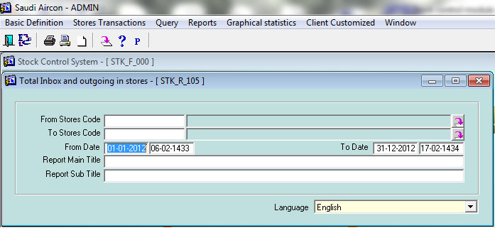

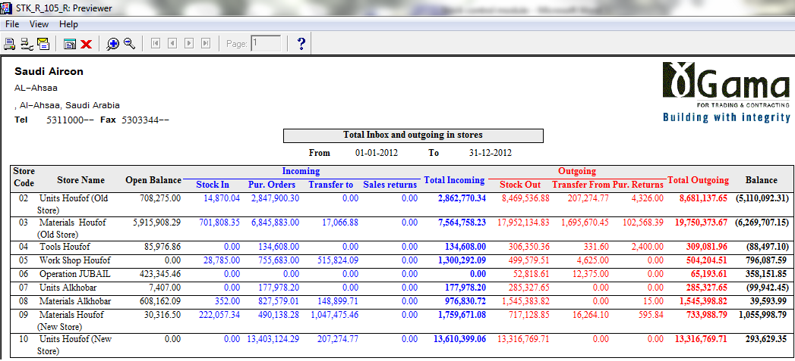

5.stores transactions within a period

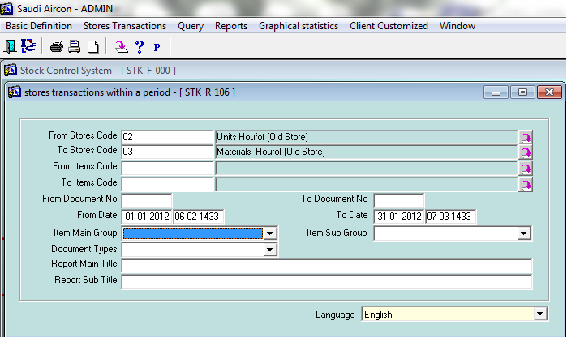

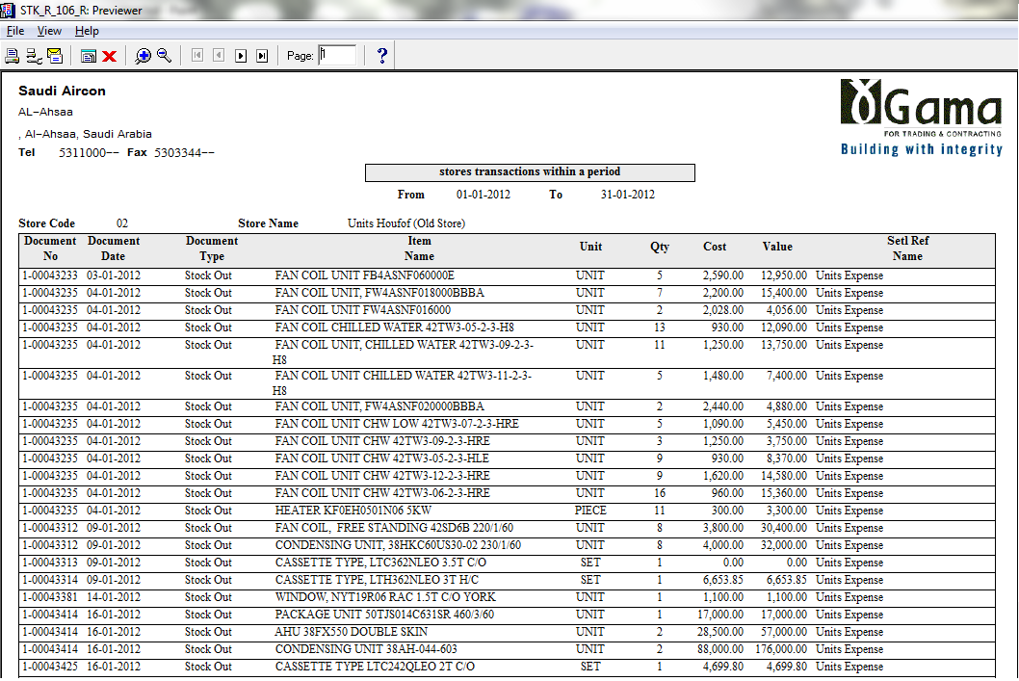

6.transfers transactions within a period

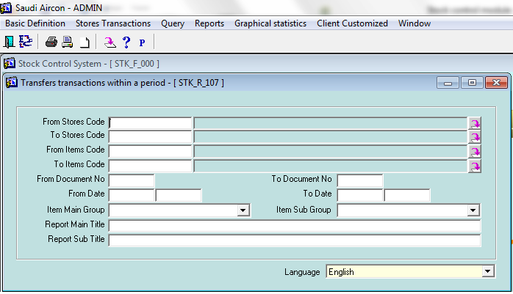

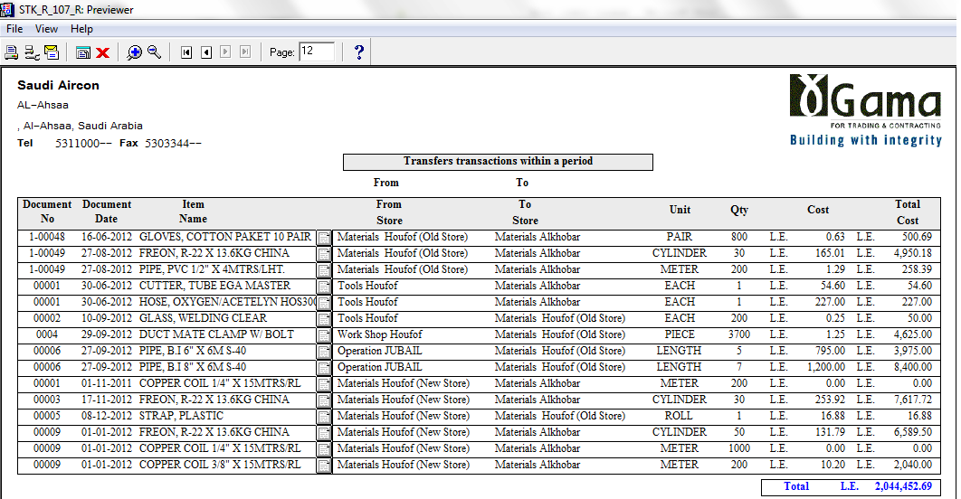

7.supplies transactions within a period

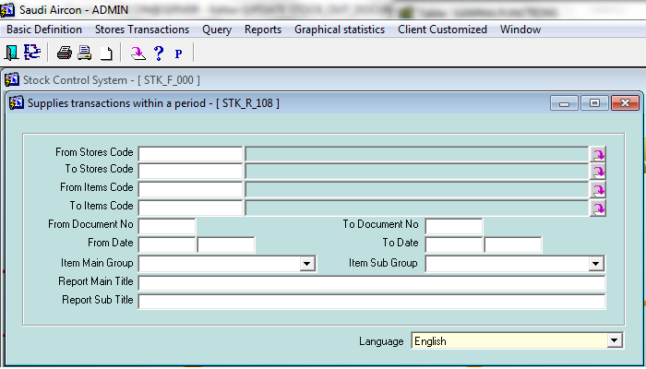

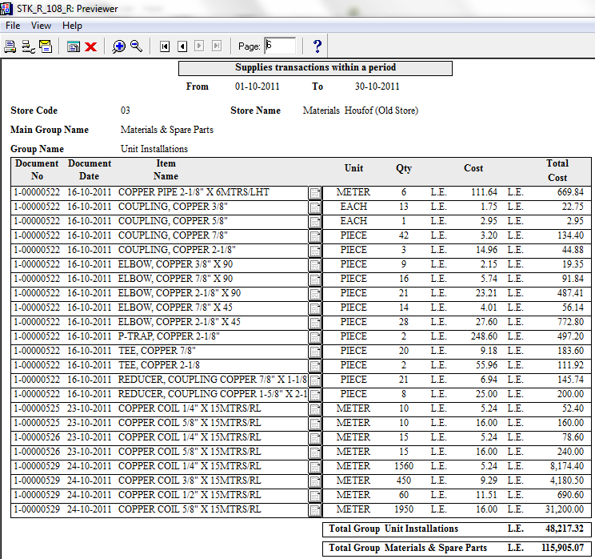

8.unmovable items in stores within a period

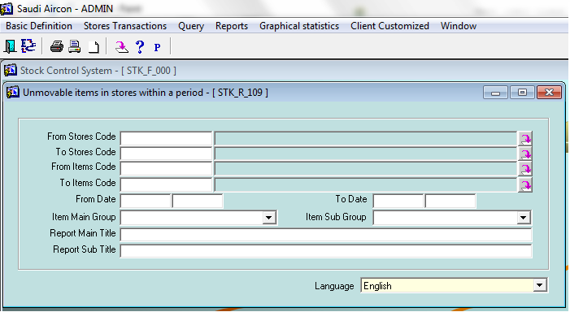

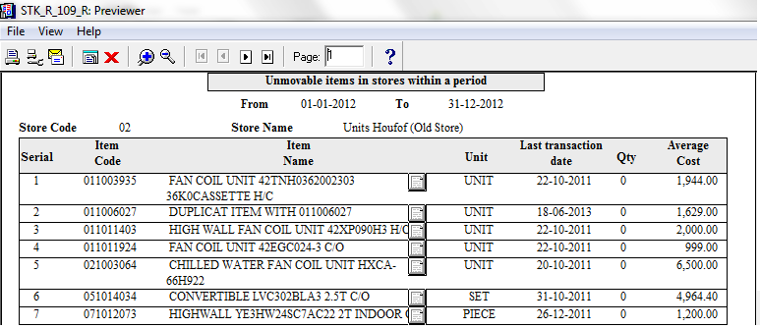

9.Projects outgoing cost clauses

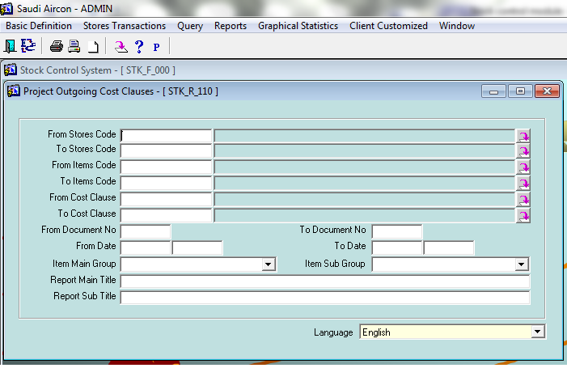

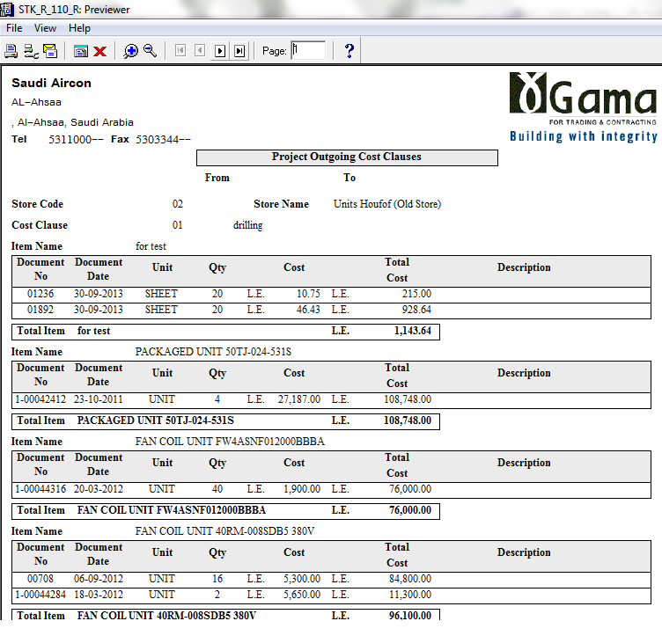

10.items locations in stores

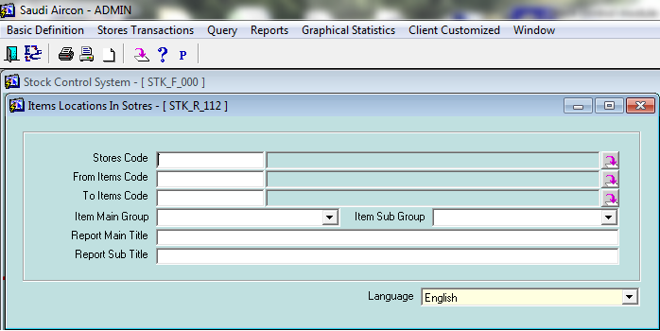

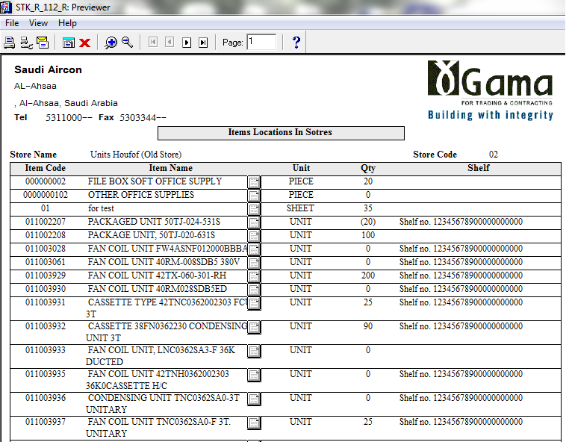

11-store evaluation: add item price to items data and control whether user display price or not:

